**ADDING SECRET TO ISTIO-SYSTEM NAMESPACE**

If any application team wants to use **TLS: simple** and wants their secret to be added to istio-system namespace, ask them to create the secret in their namespace.

1. Once the user confirms that the secret has been added in their namespace, run below command:  
     
    **kubectl get secret <secret-name> -n <namespace> -o yaml > app-sec.yaml**
2. Edit the yaml file and remove metadata/runtime entities such that the yaml is left with only below info:

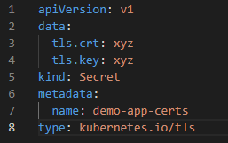

1. Save the file.
2. Run below command to add the secret to istio-system namespace:

**kubectl apply -f app-sec.yaml -n istio-system**

1. Check if the secret is present in istio-system namespace:

**kubectl get secret -n istio-system**

1. Let the user know that the secret has been added to istio-system namespace with the name specified in the yaml.